SPX Chart Analysis

The SPX is in a bull. I think the SPX will continue to rise either to its monthly or weekly resistance trendlines.15 minute chart looks like a double top is taking place. Could swing down.

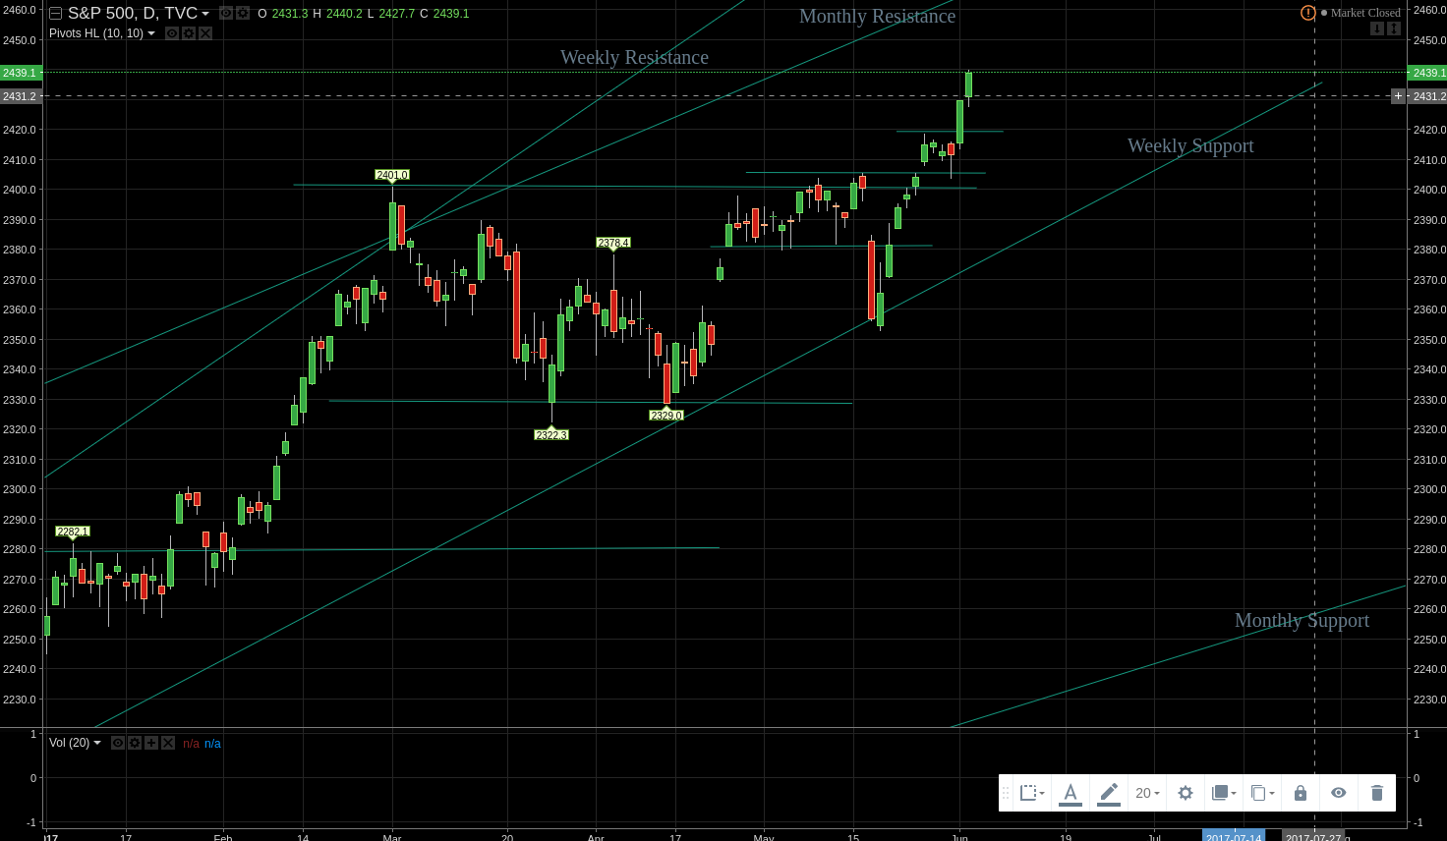
Daily chart:

Weekly Chart:
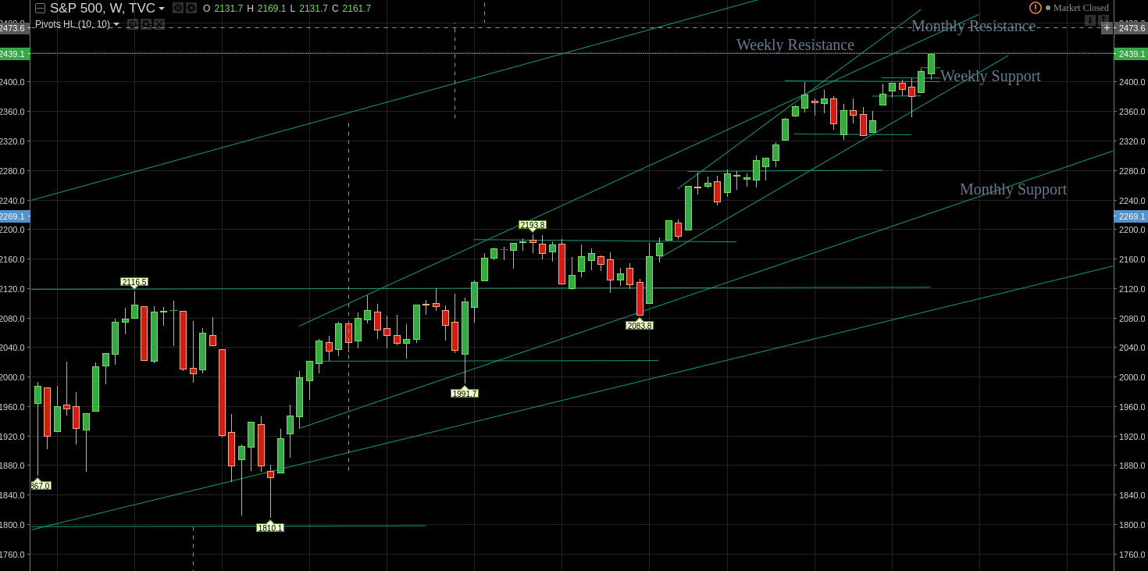

Monthly Chart:
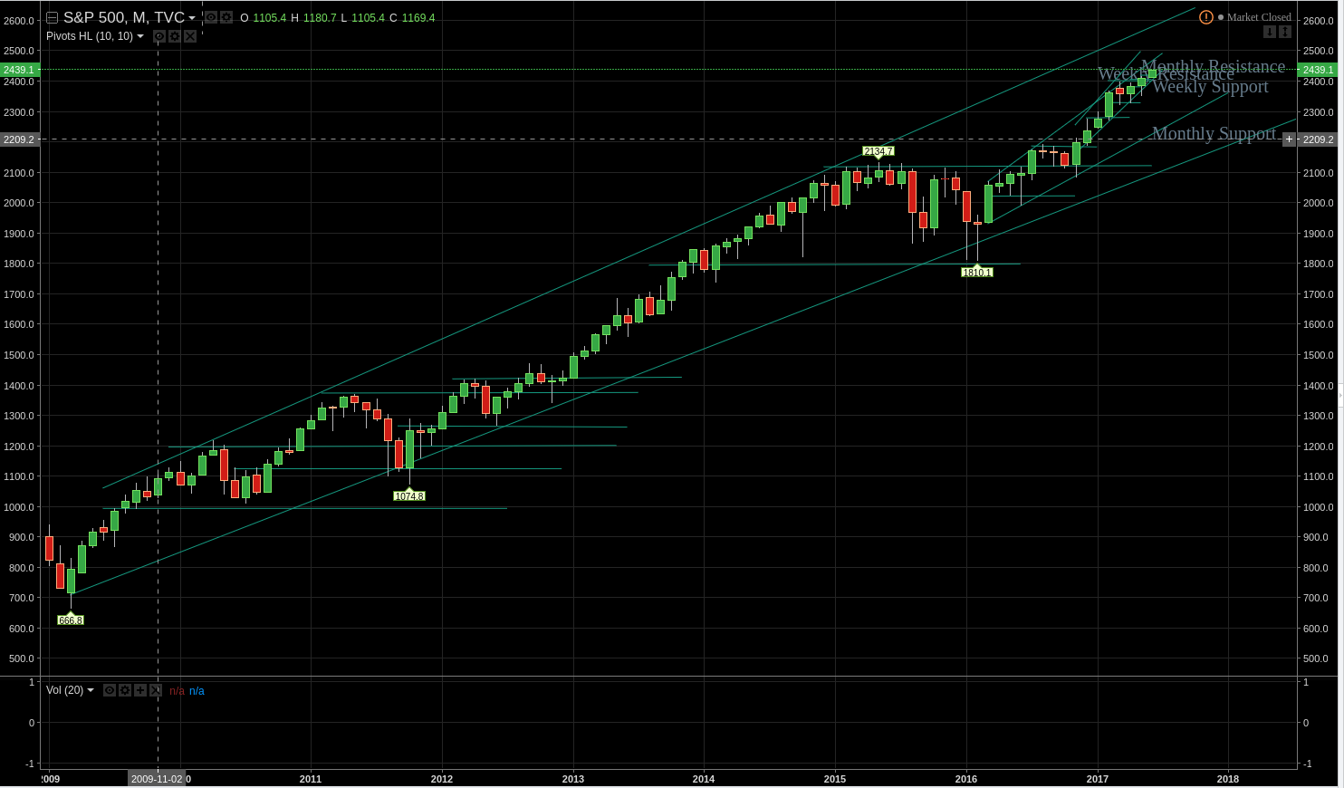
Hourly:
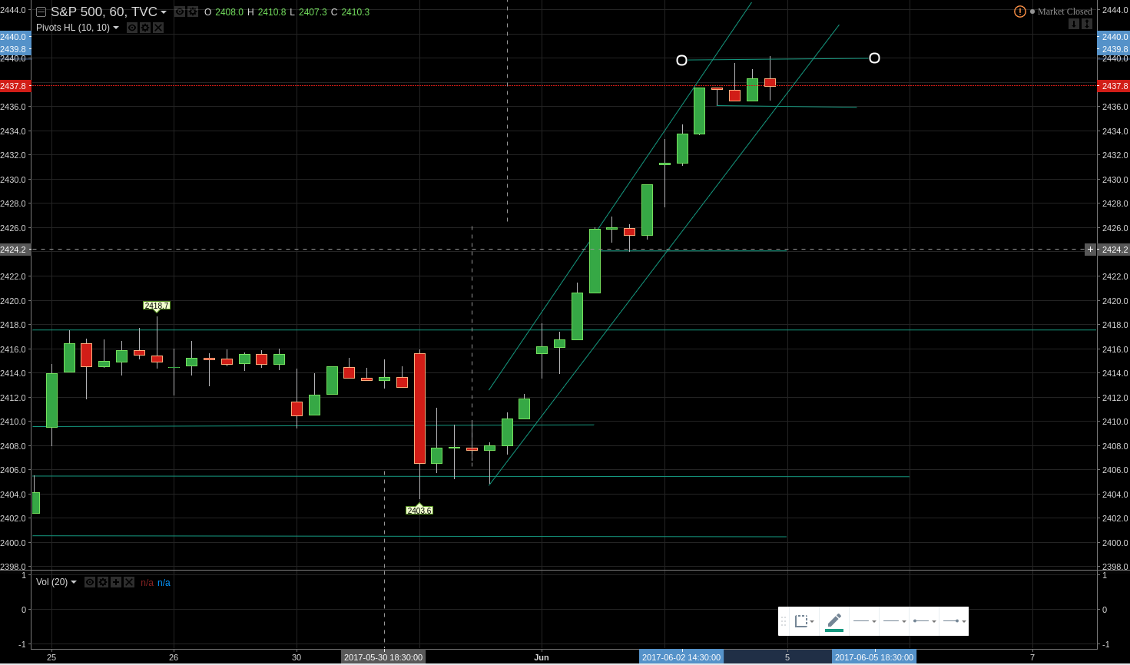
15 minute:
